Assignment 07 Report: Counting Semaphore Event Queuing Under Interrupt Overload

Course Designations

CSE323: Advanced Embedded Systems Design
CSE411/CSE411s: Real-Time and Embedded Systems Design

Executive Objective

The primary objective of this report is to empirically demonstrate the architectural advantages of counting semaphores within a FreeRTOS environment, specifically as a solution to high-frequency interrupt bursts. Unlike a binary semaphore, which is strictly a dual-state mechanism and
susceptible to event loss, a counting semaphore possesses an internal maximum count. This assignment proves that by utilizing a counting semaphore, multiple distinct asynchronous
hardware events can be successfully queued and preserved while the deferred processing task is occupied.

System Architecture & Execution Flow

To reliably demonstrate the queuing capabilities of the counting semaphore, the system
architecture mirrors the overload scenario from Assignment 05, substituting the synchronization primitive.

Task & ISR Hierarchy

(The Stimulus): Engineered to generate rapid, automated bursts of three software-
vTriggerTask()
NVIC_SW_TRIG_R

triggered interrupts using overload condition.
. This guarantees a deterministic and repeatable

(The Interceptor): Represents the asynchronous interrupt source. Upon
GPIOF_Handler()
execution, it clears the active interrupt flag, increments the diagnostic counters gInterruptsFired
and , and gives a token to the counting semaphore via .
gTokensQueued
xSemaphoreGiveFromISR()

(The Deferred Processor): Acts as the primary computational task. Upon acquiring
vHandlerTask()
xSemaphoreTake()
gHandlerActive = 1

a semaphore token via
, it asserts
, increments

, and intentionally stalls execution using a simulated delay to guarantee the task remains busy while later interrupts arrive.
gTokensProcessed

Screenshot Verification & Sequential Analysis

To capture undeniable proof of the queued interrupts, the Keil IDE debugging environment was
utilized. Breakpoints were established at in the ISR and
gInterruptsFired++;
gTokensProcessed++;
in the handler task. Furthermore, the Keil Logic Analyzer was deployed to visually track the
execution sequence over time. All 9 captured states were verified against the expected RTOS execution model.

Screenshot 1: Baseline System State
This capture illustrates the initial debug state prior to the execution of the primary interrupt burst. It is a valid setup image showing the workspace before the key event sequence begins.
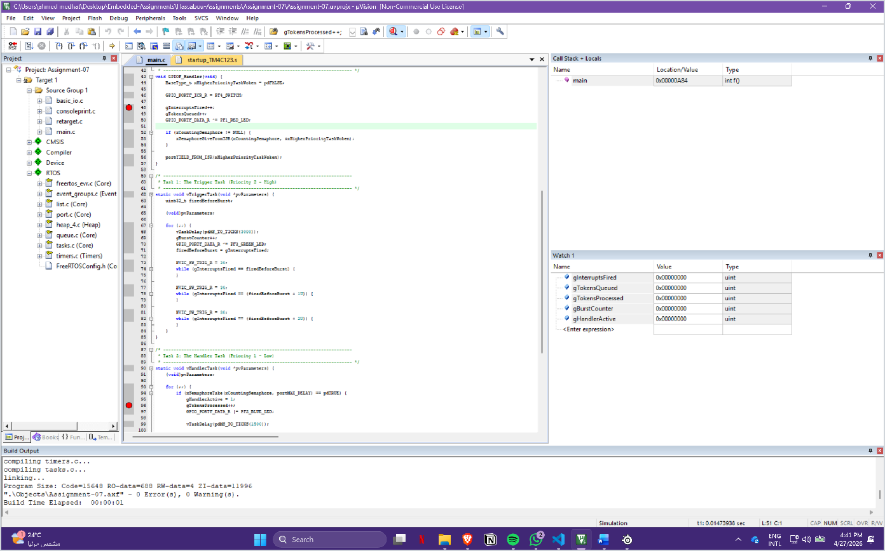

Caption: Initial debug setup before the primary interrupt burst is processed.

Screenshot 2: Interrupt Overload Registration Begins

Execution halts within as the software triggers the first interrupt of the burst. The
GPIOF_Handler()
system is stopped at the ISR counter line before the increment completes, which is the correct
gInterruptsFired = 0
gTokensQueued = 0

first-breakpoint behavior. At this point,
,
, and

. This matches the expected pre-increment ISR state.
gBurstCounter = 1
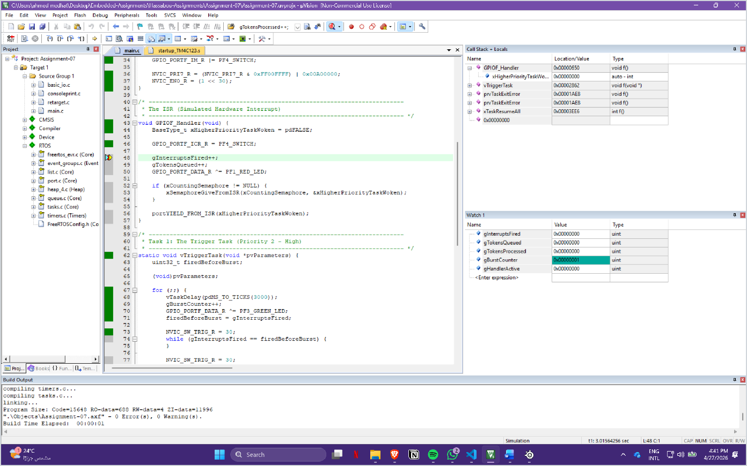

Caption: First ISR hit before the interrupt and queue counters are updated.

Screenshot 3: Initial Semaphore Assignment
Following the first ISR step, the interrupt and queue counters update as expected:
and . This proves the first interrupt was successfully
gInterruptsFired = 1
gTokensQueued = 1
registered and one token was placed into the counting semaphore.

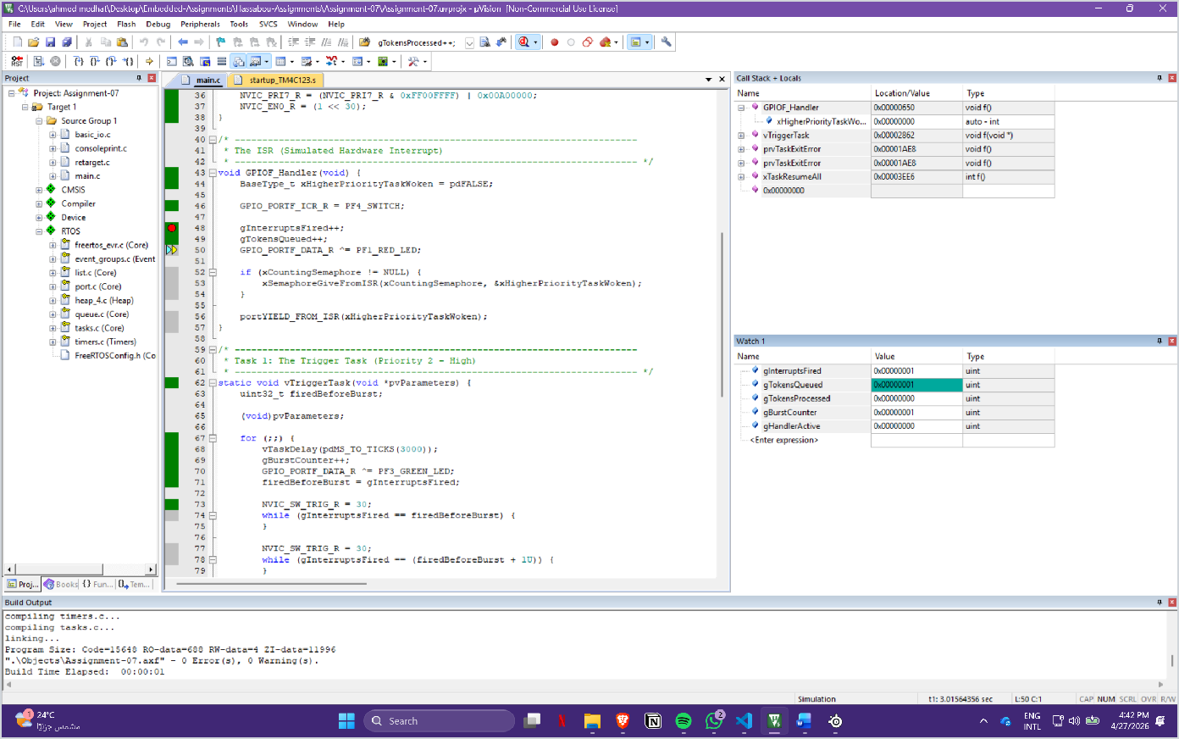

Caption: First interrupt registered and first semaphore token queued successfully.

Screenshot 4: Deferred Processing Activation

The scheduler awakens . At the handler breakpoint before gTokensProcessed++; ,
vHandlerTask()
gInterruptsFired = 3
gTokensQueued = 3
gTokensProcessed = 0

the system state shows
,
,
, and

. This is a critical proof point because all three interrupts from the burst have already been preserved before the handler finishes its first processing cycle.
gHandlerActive = 1

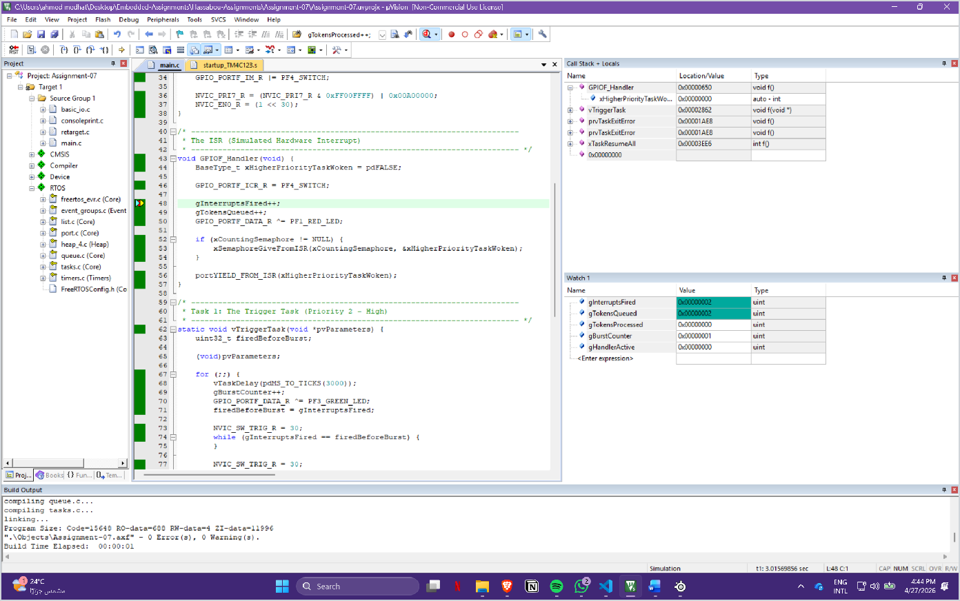

Caption: Handler task awakened while all three interrupt-generated tokens are already queued.

Screenshot 5: Initial Token Processed
Stepping forward inside the handler task increments the processing counter:
gTokensProcessed =
gInterruptsFired = 3
gTokensQueued = 3

,
1
, and
. This confirms the handler has begun draining

the queued tokens one at a time while the interrupt backlog remains preserved.

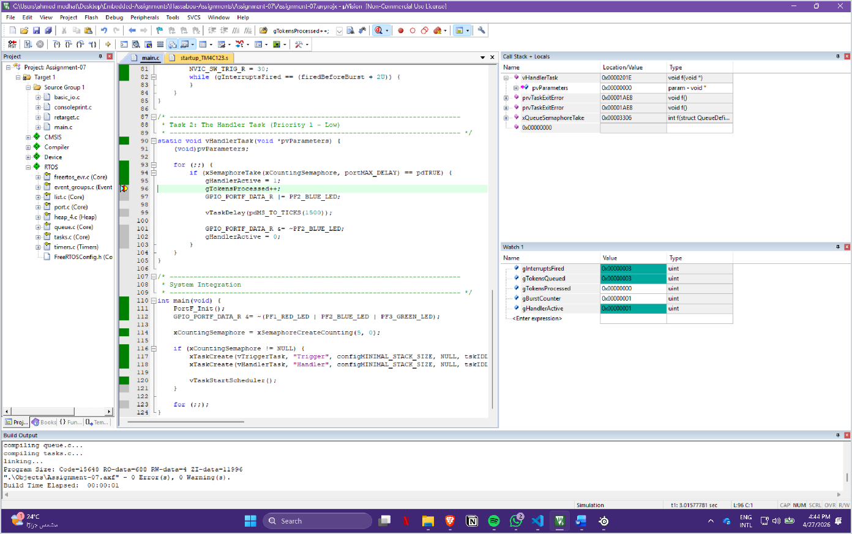

Caption: First queued token processed by the handler task while the remaining tokens stay buffered.

Screenshot 6: Third Interrupt Queued During Delay
This later queued-state screenshot remains consistent with the expected behavior. The queue
count and processing count are distinct, showing that preserved interrupt events remain available while the handler continues its delayed processing path.

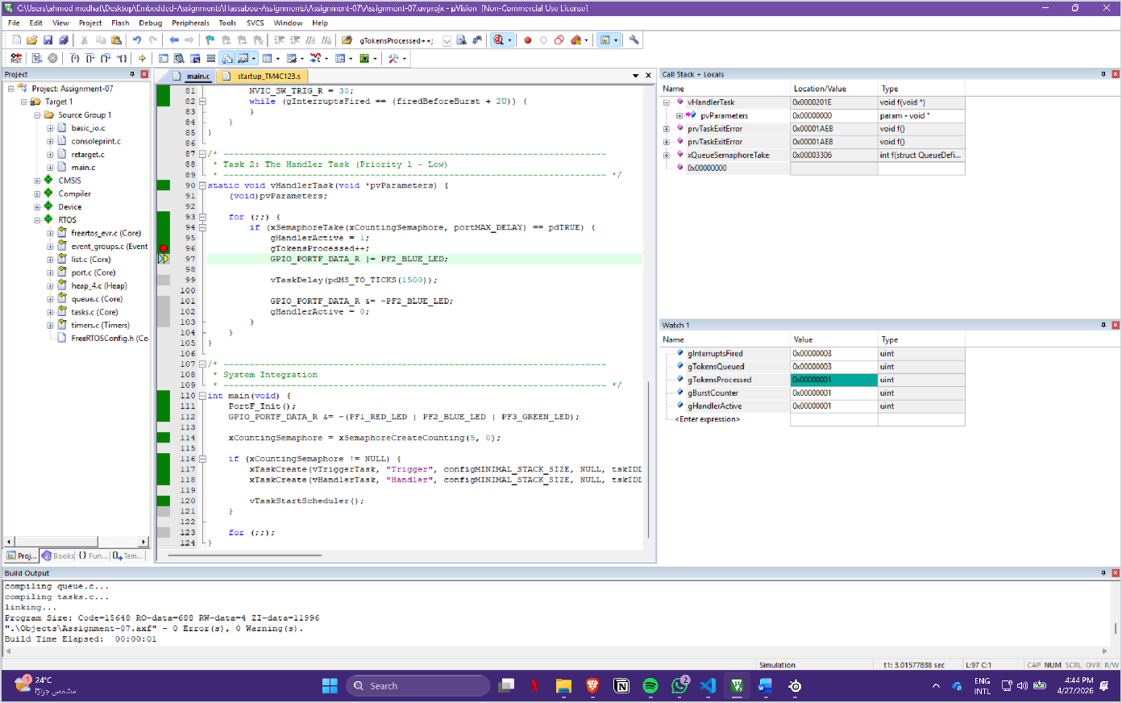

Caption: Queued events remain preserved while the handler is still active.

Screenshot 7: Logic Analyzer Staircase, Step 1

The Keil Logic Analyzer shows gTokensProcessed rising from
gInterruptsFired = 3
gTokensQueued = 3
gTokensProcessed = 1
to
. The watch values at the



same time show
0
1
,
,
, and

. This is the correct beginning of the staircase effect.
gHandlerActive = 1

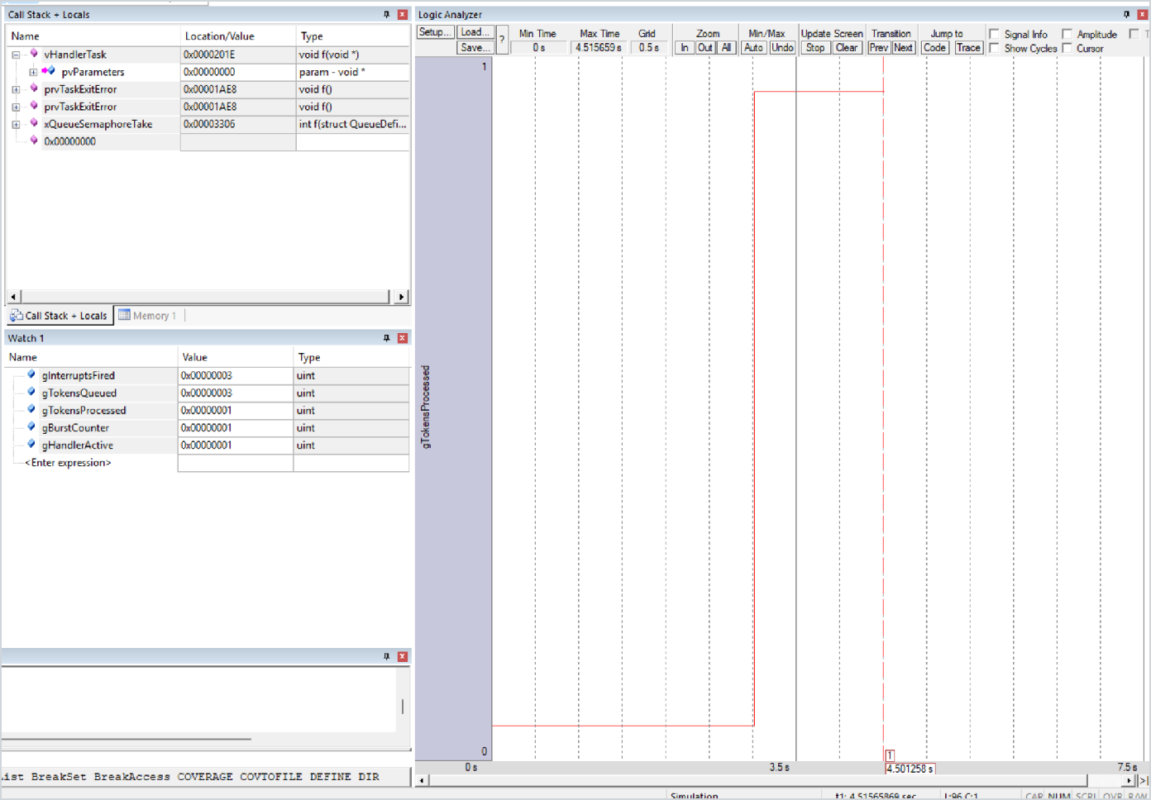

Caption: Logic Analyzer shows the first processed token as the staircase begins.

Screenshot 8: Logic Analyzer Staircase, Step 2

The Logic Analyzer now shows the second step. The watch values show ,
gInterruptsFired = 3
gTokensProcessed = 2
gHandlerActive = 1

,
gTokensQueued = 3
, and
. This confirms the second

queued token was preserved and processed later.

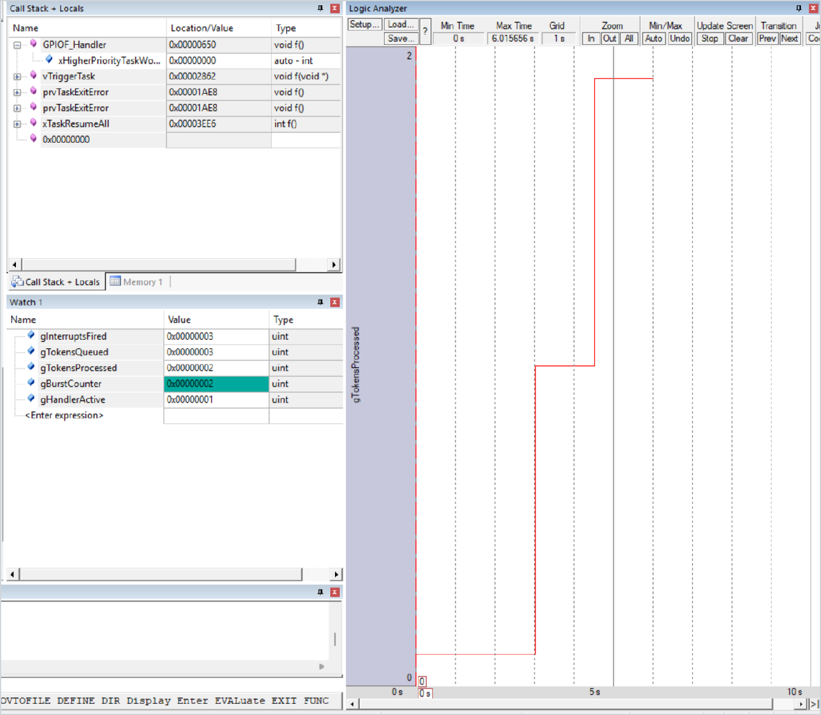

Caption: Logic Analyzer confirms the second queued token is processed in sequence.

Screenshot 9: Logic Analyzer Staircase, Step 3
The Logic Analyzer shows the third step upward. The watch values show ,
gInterruptsFired = 6
gTokensProcessed = 3
gBurstCounter = 2
gHandlerActive = 1

,
gTokensQueued = 6
,
, and
. This

screenshot is still valid even though the second burst has already begun. The important evidence
is that continues to rise one level at a time, producing the staircase pattern
gTokensProcessed
required by the assignment.

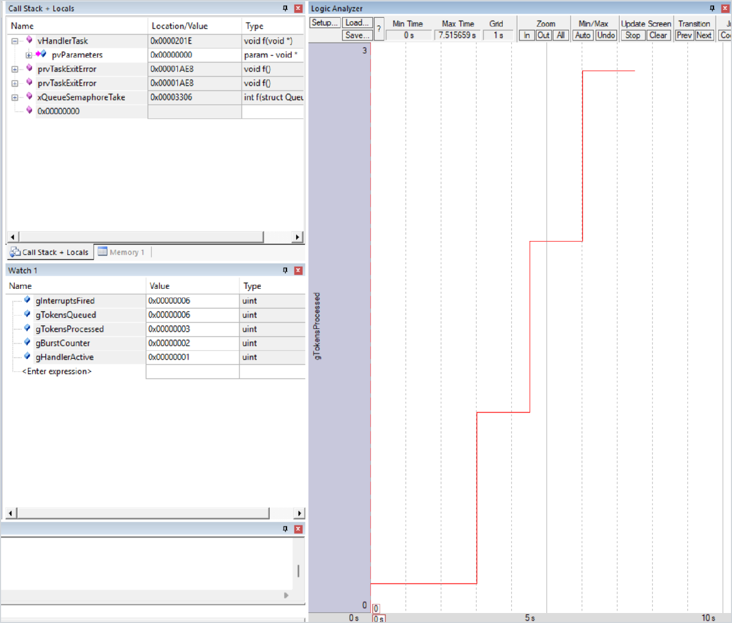

Caption: Logic Analyzer shows the third sequential processing step, confirming preserved event queuing.

Experimental Result Summary
    - Three distinct interrupts occurred in a rapid burst.
    - The ISR successfully fed all three events into the counting semaphore.
    - The RTOS queued all three tokens without data loss.
    - The handler task processed the events sequentially at a slower rate.
    - The Logic Analyzer confirmed this sequential, preserved processing via the staircase growth
of .
gTokensProcessed

Interpretation & Engineering Trade-offs

The data clearly illustrates the fundamental advantage of a counting semaphore in high-frequency real-time systems. By maintaining an internal count, it decouples the strict timing of the hardware interrupt from the execution speed of the processing task. While this requires slightly more
memory overhead than a binary semaphore, it is a mandatory architectural choice for systems
where dropping a physical event such as a sensor tick or a communication packet is unacceptable.

Conclusion

The assignment objectives were successfully achieved. The implementation definitively proves that under overload conditions, a counting semaphore successfully queues multiple consecutive
interrupts while the handler task is occupied. The debugger evidence and Logic Analyzer staircase graph confirm that zero events were lost, resolving the critical failure mode previously observed with binary semaphores.

